11.
from sklearn.tree import DecisionTreeClassifier
X=[[500],[600],[700],[800]]
y=['Poor','Fair','Good','Excellent']
m=DecisionTreeClassifier()
m.fit(X,y)
print(m.predict([[750]]))
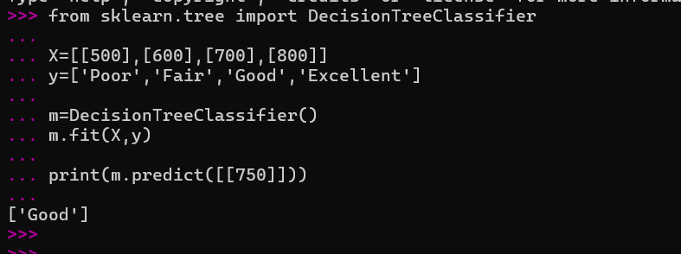
12.
from sklearn.datasets import load_iris
from sklearn.neighbors import KNeighborsClassifier
X,y=load_iris(return_X_y=True)
m=KNeighborsClassifier()
m.fit(X,y)
print(m.predict([X[0]]))
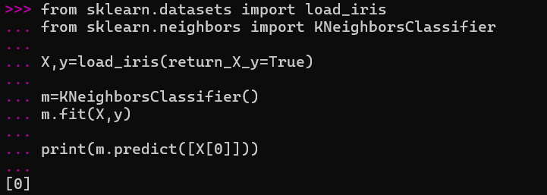

13.
from sklearn.linear_model import LinearRegression
X=[[1],[2],[3],[4]]
y=[100000,200000,300000,400000]
m=LinearRegression()
m.fit(X,y)
print(m.predict([[5]]))
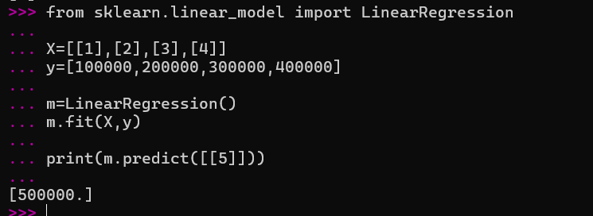
14.
from sklearn.linear_model import LinearRegression
X=[[500],[1000],[1500],[2000]]
y=[20,40,60,80]
m=LinearRegression()
m.fit(X,y)
print(m.predict([[2500]]))
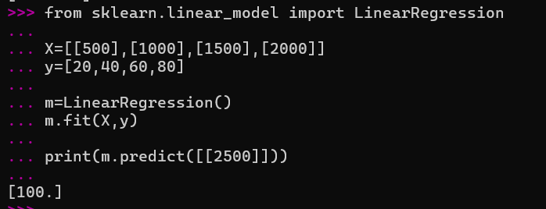

15.
from sklearn.datasets import load_iris
from sklearn.naive_bayes import GaussianNB
X,y=load_iris(return_X_y=True)
m=GaussianNB()
m.fit(X,y)
print(m.predict([X[0]]))
